**Assignment**

**Code:**

|  |
| --- |
| # This is a ticket class where user details are saved class Ticket:  # This is a Ticket class constructor  def __init__(self, staffID, name, email, description):  self.staffID = staffID  self.name = name  self.email = email  self.description = description  self.response = "Not Yet Provided"  self.status = "Open"   def __str__(self):  return f"Ticket Number: {self.ticketNumber} \nTicket Creator: {self.name} \nStaff ID: {self.staffID} \nEmail Address: {self.email} \nDescription: {self.description} \nResponse: {self.response} \nTicket Status: {self.status}\n"   #This is a help desk class  class HelpDesk:  ticketNumber = 2000  openTickets = 0  closedTickets = 0  # This is a HelpDesk class constructor  def __init__(self):  self.tickets = []  #This is a submit ticket function  def submitTicket(self, staffID, name, email, description):  newTicket = Ticket(staffID, name, email, description)  self.tickets.append(newTicket)  newTicket.ticketNumber = HelpDesk.ticketNumber  HelpDesk.ticketNumber += 1  #password change request are process in this if block  if "Password Change" in description:  newTicket.response = f"New Password: {staffID[:2]}{name[:3]}"  HelpDesk.closedTickets += 1  newTicket.status = "Closed"  return newTicket   # This is a respondToTicket function  def respondToTicket(self, ticketNumber, response):  for ticket in self.tickets:  if ticket.ticketNumber == ticketNumber:  ticket.response = response  ticket.status = "Closed"   # This is a reopenTicket function  def reopenTicket(self, ticketNumber):  for ticket in self.tickets:  if ticket.ticketNumber == ticketNumber:  ticket.status = "Reopened"   # This is a displayTicket function  def displayTicket(self, ticketNumber):  for ticket in self.tickets:  if ticket.ticketNumber == ticketNumber:  print(ticket)  #This displayStatistics function displays the stats of users ticket  def displayStatistics(self):  print(f"Number of tickets Created: {HelpDesk.ticketNumber - 2000} \nNumber of resolved tickets: {HelpDesk.closedTickets} \nNumber of tickets to solve: {HelpDesk.openTickets}")    def main():  # Creating object of HelpDesk class  helpDesk = HelpDesk()  print('\n\n------------Printing Tickets------------\n')  # Passing parameters (which contains user id, name, email and query) in submitTicket function of HelpDesk class  helpDesk.submitTicket("25896", "John", "john@gmail.com", "Password Change")  helpDesk.submitTicket("36525", "Butler", "butler@gmail.com", "Password Change")  helpDesk.submitTicket("19252", "Mike", "mike@gmail.com", "Password Change")  # Passing parameters in respondToTicket function of HelpDesk class to response user query  helpDesk.respondToTicket(2000, " New password generated: vnwdu87")  helpDesk.respondToTicket(2001, " New password generated: abnegeu43")  helpDesk.respondToTicket(2002, " New password generated: jemn90u")  # Displaying tickets of user  helpDesk.displayTicket(2000)  helpDesk.displayTicket(2001)  helpDesk.displayTicket(2002)  print('\n\n------------Displaying Ticket Statistics------------\n')  # Displaying user stats of tickets  helpDesk.displayStatistics()   main() |

**Output:**

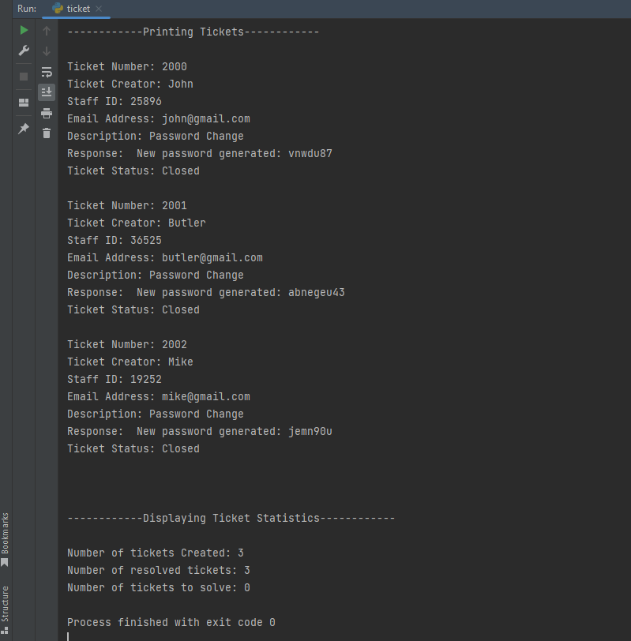

**Description :**

In this Ticket system program, the detail of the user is being saved in a list that mainly contains the staff id, name, email address, and description. All these parameters are sent in the submitTicket function where these queries are entertained and finally, the program displays the Ticket statistics which contain the total no of tickets, the total no of resolved tickets, and no of tickets to solve.